

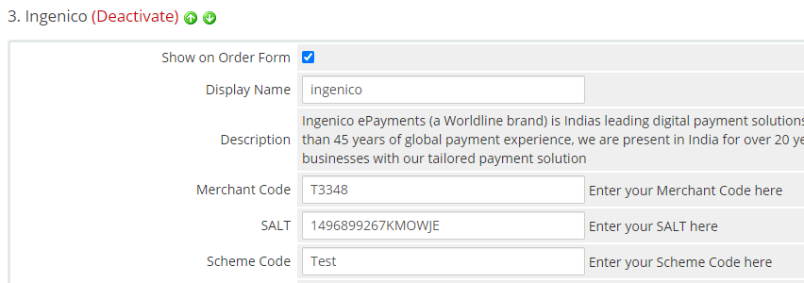
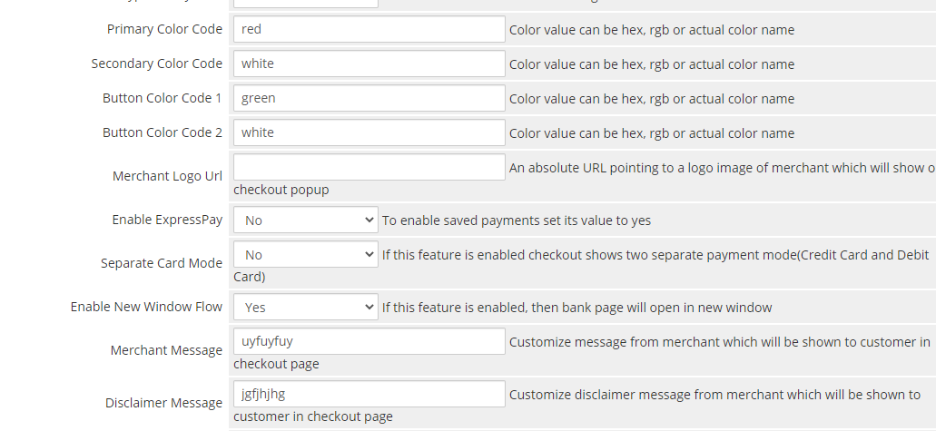
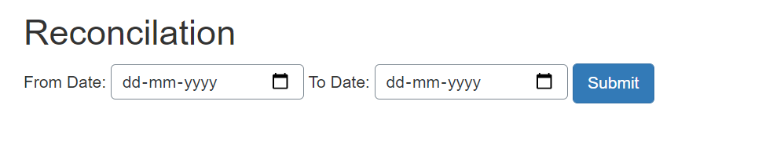
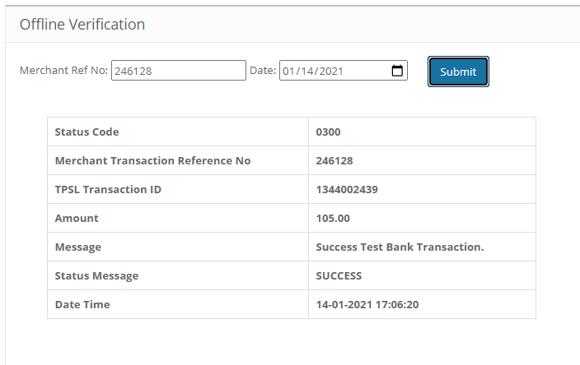
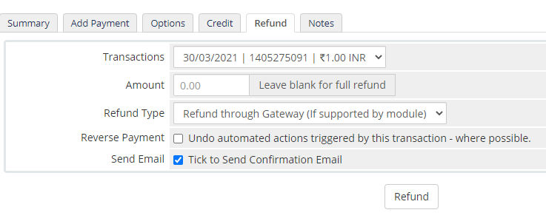



INSTALLATION MANUAL

Table of Contents

Applicable Version………………..…....……………………………….……………………….1

Installation....………………………….……….……………………………………………………1

Configuring worldline………………..……………………………………………………………3

Applicable versions

Applications | Versions
PHP | 7x
WHMCS | 8x

Installation & Upgrade

Please follow the given steps to install and run the worldline Payment Gateway module

1. Copy all files/folders recursively to WHMCS installation directory
2. Go to System Settings >Payment Gateways > All Payment Gateways and install the worldline gateway extension.


Update Plugin

1. Deactivate worldline and delete the existing worldline files
2. After the successful uninstallation, install the updated worldline package as mentioned above.

Configuring worldline

- Go-to Manage Existing Gateways
- Scroll down. You will see worldline, Edit it
- Configure it as below:
Column Name | Description
Name | worldline
Merchant Code | Enter Merchant Code
Salt | Enter Salt.
Payment Type | For Test mode Select ‘Test’ and for Live mode select ‘Live’
Merchant Scheme Code | Enter Scheme Code

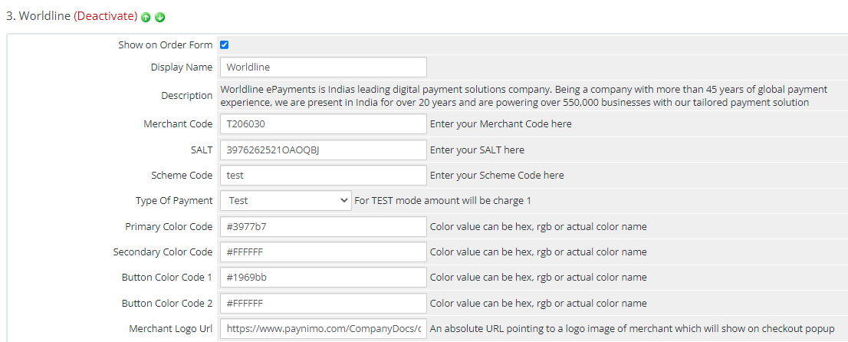
- Now click on “Save Changes”.
- worldline Payment Gateway is now configured & ready to use.

Advanced Configuration

There are also some advanced configuration options you may consider as shown below:

Features List

Dual verification of response
We are validating responses with a hash value and call again Payment Gateway for dual verification from the payment gateway before updating to the order status.

Reconciliation

Merchants can update the pending status of the order automatically if the payments are successful. This page can be found under Manage Existing Gateways>worldline->Scroll down>Reconciliation

Logs request and response

Daily new file creates for the logs request and response from the server for future reference.

S2S Verification
If we do not receive any response from the payment gateway then after 30 mins, we will get a response from the server and based on the response it will update order status.
To configure S2S URL, contact prod team.

S2S url format : hostname/modules/gateways/callback/worldline.php?action=s2sverification&msg=
S2S url example:
http://example.com/modules/gateways/callback/worldline.php?action=s2sverification&msg=

MCG
It supports the multi currency like USD, GBP, SGD and a lot more.

Offline Verification

Merchants can verify the status of their payment by using the Payment Verification page. The payment verification page can be found under Manage Existing Gateways>worldline->Scroll down>Offline Verification

Refund
Merchants should be able to process the refund online for the order whose payment has been done via worldline.

To refund an order go to billing>invoices>select the invoice>click on refund tab

Embed Payment Gateway

After enabling this setting, payment gateway displays like embedded on the page instead of pop-up so user experience would be good.

Documentation link
https://www.tecprocesssolution.com/proto/p2m/client/salt-based-documentation.htm#online

